Table of Content

Table of Content 1
ISIS 1
Prefix Suppression 1
Hello Padding 3
Overload Bit 5
LSP Size 8
Default Metric 9
Hello/Hold Timer 11
Mesh Groups 12
Prefix Summarization 14
Default Route Preference 17
ISIS Timers 20
Log Neighbor Changes 21
Troubleshooting 1 – No routes 23
Troubleshooting 2 – Adjacency 24
IPv6 Single Topology 26
Ipv6 Single Topology Challenge 27
IPv6 Multitopology 29
IPv6 Single to Multitopology 30
Wide Metrics 32
Route Filtering 34
Backdoor Link 35
Non-Optimal Intra-Area Routing 37
Multi Area 38

BGP

Lab1 ECMP

Load Config
# IOL
configure replace unix:labconfigs/lab1.init.cfg force

The idea behind these labs is that R6 is advertising 192.0.2.6/32 and 2001:db8::6/128. It is multi-homed to R4 and R5. We will use various techniques to achieve load balancing and failover.
This first lab requires you to configure ECMP.
Currently R2 and R3 are using R4 for egress due to its lower RID. R6 is using R4 for this reason as well.
Configure the fewest number of routers so that traffic from R1 to R6 is load balanced through R4 and R5, and return traffic from R6 is likewise load balanced.

Answer

# R3
router bgp 65000
address-family ipv4
maximum-paths ibgp 2
address-family ipv6
maximum-paths ibgp 2

# R6
router bgp 65006
address-family ipv4
maximum-paths 2
address-family ipv6
maximum-paths 2

Explanation

Lab2 UCMP
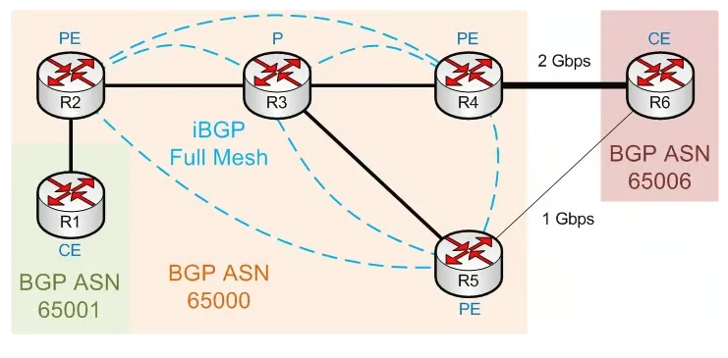

Load Config
# IOL
configure replace unix:labconfigs/lab2.init.cfg force

The bandwidth of the R4-R6 and R5-R6 link has been changed, matching the diagram above.
- Configure UCMP so that R3 will send twice as much traffic to R4.
- Additionally, configure R6 to send twice as much traffic to R4.
- Only do this for IPv4 traffic. (It doesn’t work for IPv6).

Answer
# R3
router bgp 65000
add ipv4
maximum-paths ibgp 2
bgp dmzlink-bw

# R4
router bgp 65000
template peer-policy IBGP_V4V6
send-community both
exit-peer-policy
add ipv4
bgp dmzlink-bw
neighbor 10.4.6.6 dmzlink-bw

# R5
router bgp 65000
template peer-policy IBGP_V4V6
send-community both
exit-peer-policy
add ipv4
bgp dmzlink-bw
neighbor 10.5.6.6 dmzlink-bw

# R6
router bgp 65006
add ipv4
bgp dmzlink-bw
neighbor 10.4.6.4 dmzlink-bw
neighbor 10.5.6.5 dmzlink-bw
maximum-paths 2

